**LEBANESE AMERICAN UNIVERSITY**

**USAID – HIGHER EDUCATION SCHOLARSHIP PROGRAM**

**HES - Volunteering Program Verification Form**

This form is to be used to document volunteering hours. If a student volunteers for multiple organizations, a separate form must be used for each organization. **This form must be turned in by the 28th of each month, the latest.**

I certify that the scholar Lynne Al Safawi completed a total of 6 hours of service at Life Sculptor.

The hours were completed hours as per the below:

Hours # 1 (date) _02/09 - 06/09_ (initials of supervisor) __A.K.___

Hours # 2 (date) _09/09 – 13/09_ (initials of supervisor) __A.K.___

Hours # 2 date) _16/09 – 20/09 (initials of supervisor) __A.K.___

Hours # 1 date) _23/09 – 27/09 (initials of supervisor) __A.K.___

Brief description of the activities the scholar performed or participated in:

As a volunteer in the PowerPoint team, I create engaging presentations on digital transformation and corporate taxation by illustrating key concepts and trends. I delve into the understanding of International Financial Reporting Standards, ensuring clarity and accessibility for diverse audiences. Additionally, I explore the transformation of financial reporting in the digital age, showcasing innovative tools and practices to enhance transparency and efficiency.

Written feedback about the scholar’s performance:

Lynn Safawi, as a volunteer in the PowerPoint team, effectively creates engaging presentations on digital transformation and corporate taxation. She illustrates key concepts and trends while ensuring clarity in International Financial Reporting Standards for diverse audiences. Lynn also explores the transformation of financial reporting in the digital age, highlighting innovative tools and practices that enhance transparency and efficiency. Her contributions are instrumental in conveying complex topics in an accessible manner.

Please rate the overall performance of the scholar at your organization:

|  |  |  |  |
| --- | --- | --- | --- |
|  | Mastery (5) | Proficient (3) | Emerging (1) |
| **Problem solver** | X |  |  |
| **Engaged & Committed** | X |  |  |
| **Open-minded & multicultural** | X |  |  |

Signature

& stamp

__________________________

_

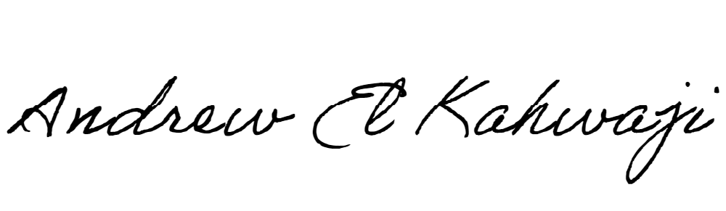

Printed Name _Andrew El Kahwaji_

Date __25/09/2024___

Email __andrew.lifesculptor.coo@gmail.com __

Phone __+961 71 914 378__

**LEBANESE AMERICAN UNIVERSITY**

**USAID – HIGHER EDUCATION SCHOLARSHIP PROGRAM**

